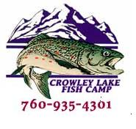

Crowley Lake Fish Camp
2019 RV Storage Registration Form
Name
Address
City
State |  |  | Zip
Home # |  |  | Cell #
Email
Make
Model
License
Date In |  | Date Out

I shall hold Crowley Lake Fish Camp, Inc. (CLFC) and the City of Los Angeles Department of Water and Power (DWP), and their stockholders, officers, agents, and employees, free and harmless from any and all claims, demands, damages, actions, and costs or expenses in connection therewith, that may arise out of the storage granted. I expressly waive any and all claims for compensation and release and discharge CLFC, and DWP, and their stockholders, officers, agents, and employees from any and all demands, claims, actions, and causes arising from any and all loss or damage. I will abide by the Rules and Regulations listed for Crowley Lake.
Signature of RV Owner (Mandatory)

Office Use Only
Date Received |  | Amount Paid
Verified By |  | Check #
Dates of Storage |  | Permit #

